**CHENDHURAN COLLEGE OF ENGINEERING AND TECHNOLOGY**

**DEPARTMENT OF CIVIL ENGINEERING**

**NAAN MUDHALVAN**

**BLOCKCHAIN TECHNOLOGY**

**ASSIGNMENT QUESTIONS**

1.Go to the chrome and open remix platform

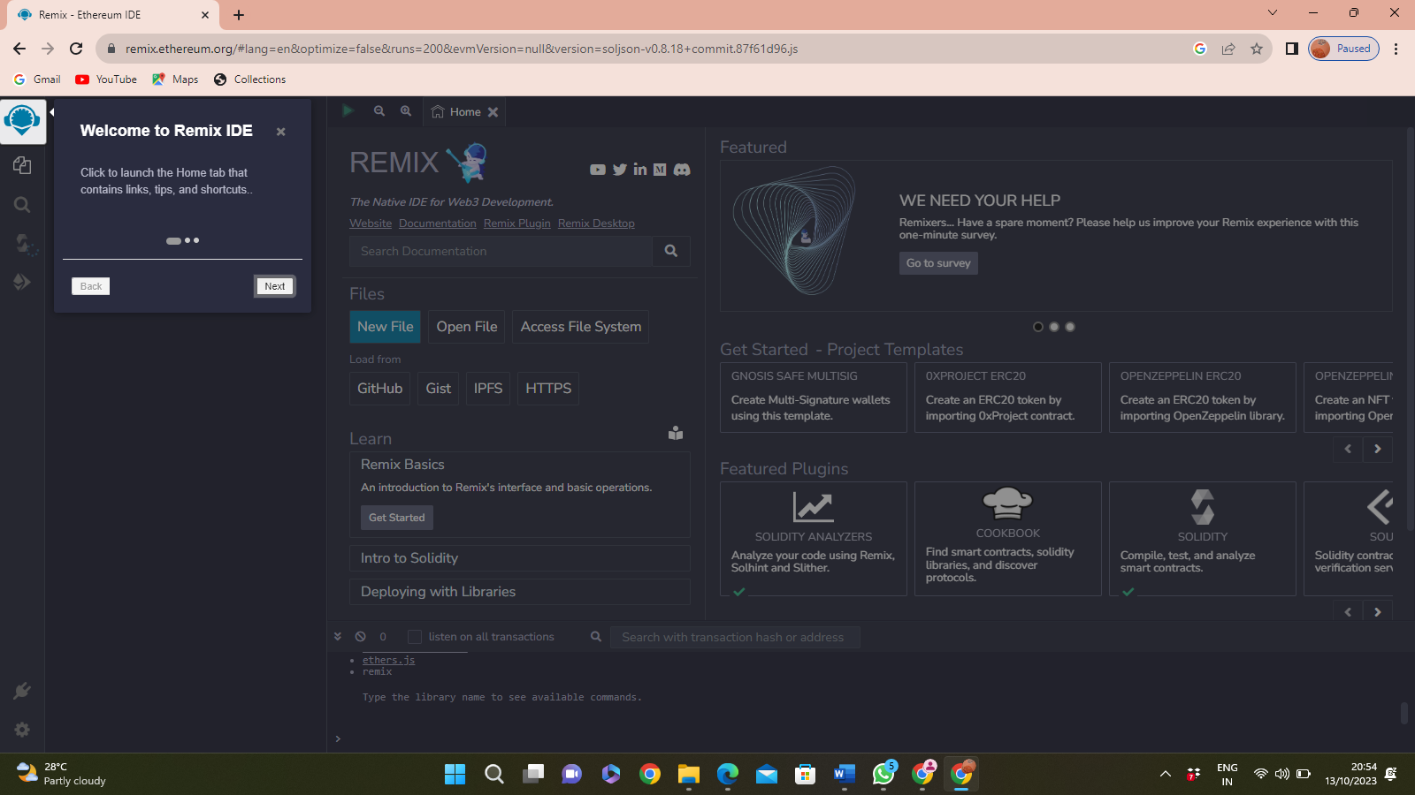

2.Open the remix page and create a new file

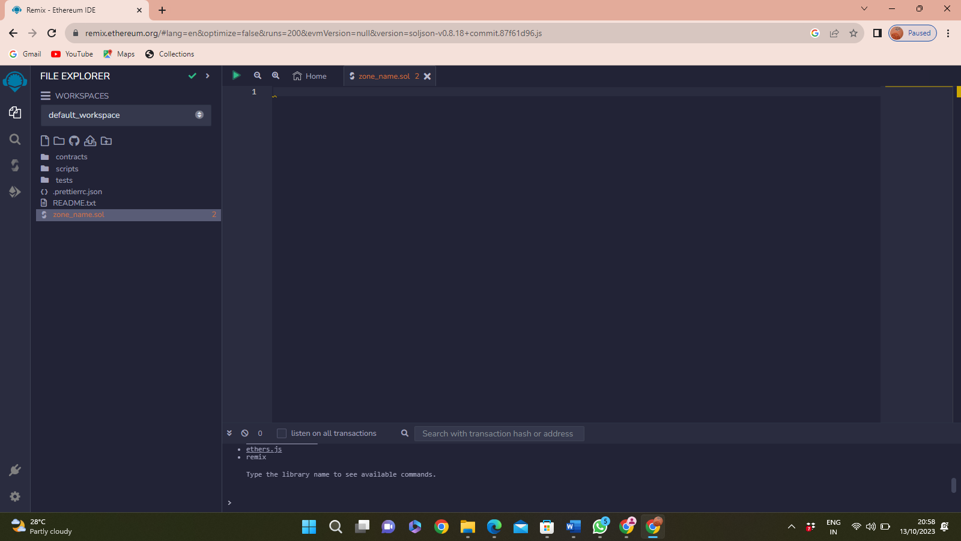

3.In that newly created file, create a program to return your string, "Zone name"

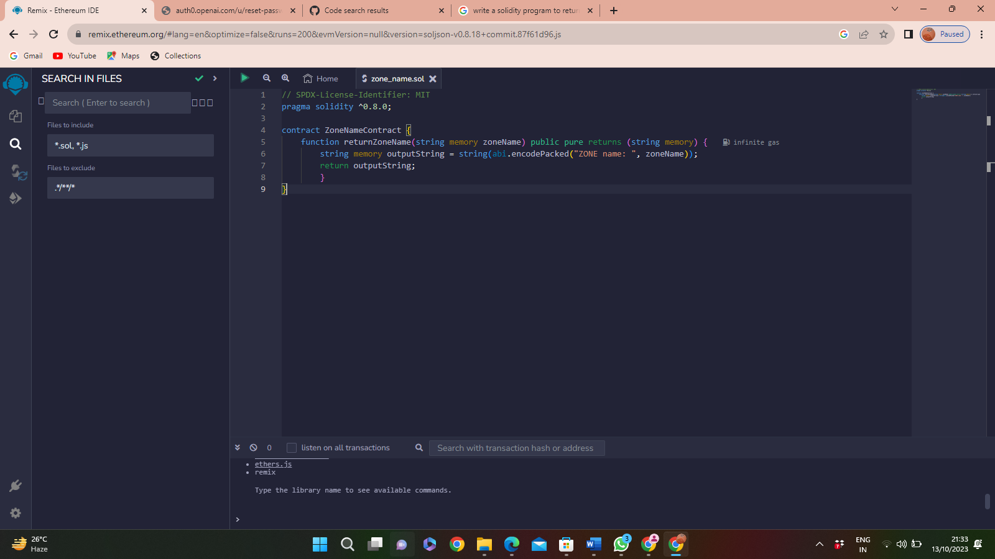

4.Save the program and compile it to get the ABI and Bytecode .

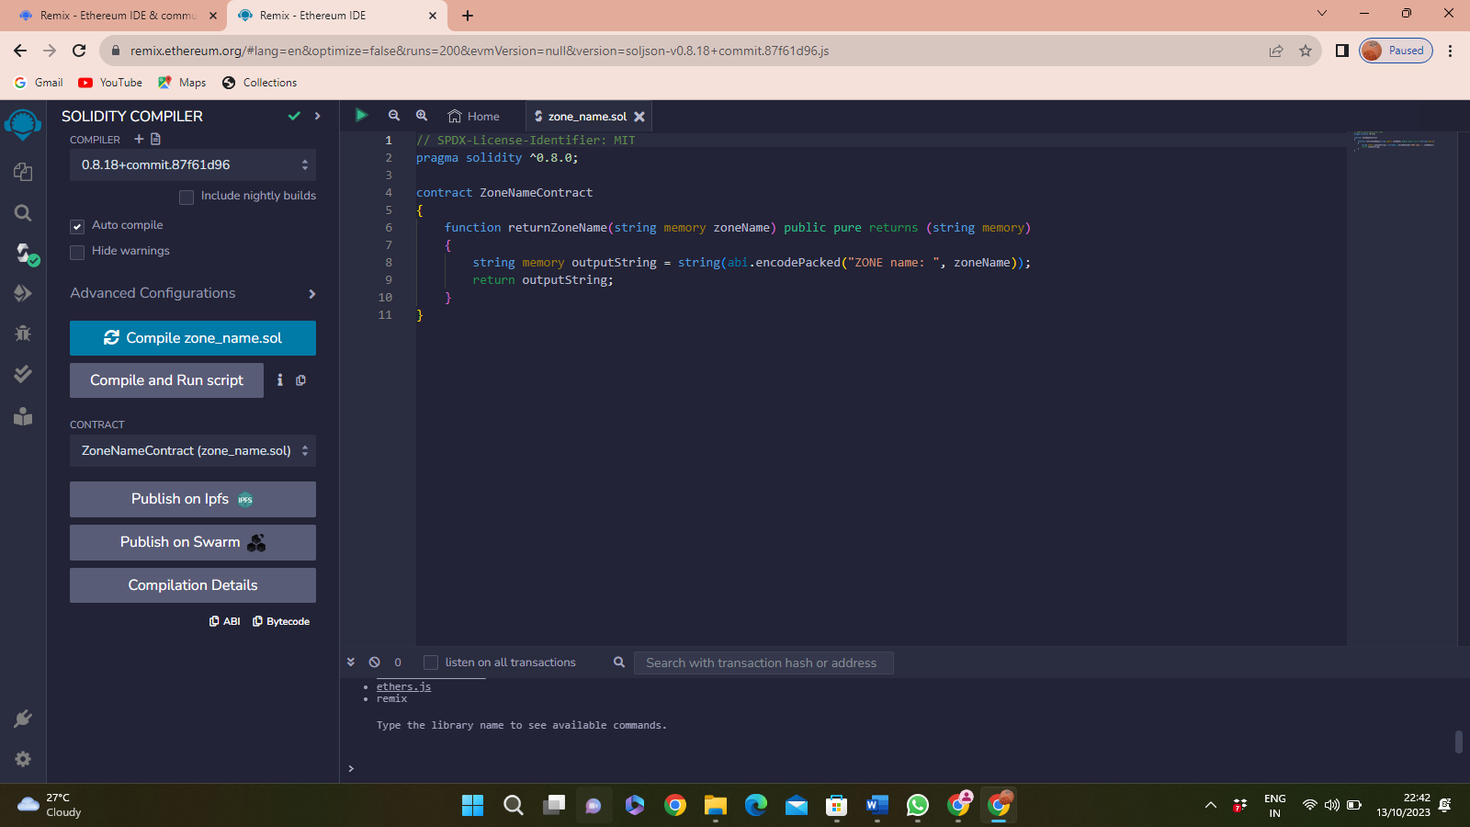

**ABI Code**

[

{

"inputs": [

{

"internalType": "string",

"name": "zoneName",

"type": "string"

}

],

"name": "returnZoneName",

"outputs": [

{

"internalType": "string",

"name": "",

"type": "string"

}

],

"stateMutability": "pure",

"type": "function"

}

]

**BYTE Code**



5.Finally Deploy it to display the output.

